# Introduction

Youtube Link: https://youtu.be/m8StZYmgFsc

## Screenshots:

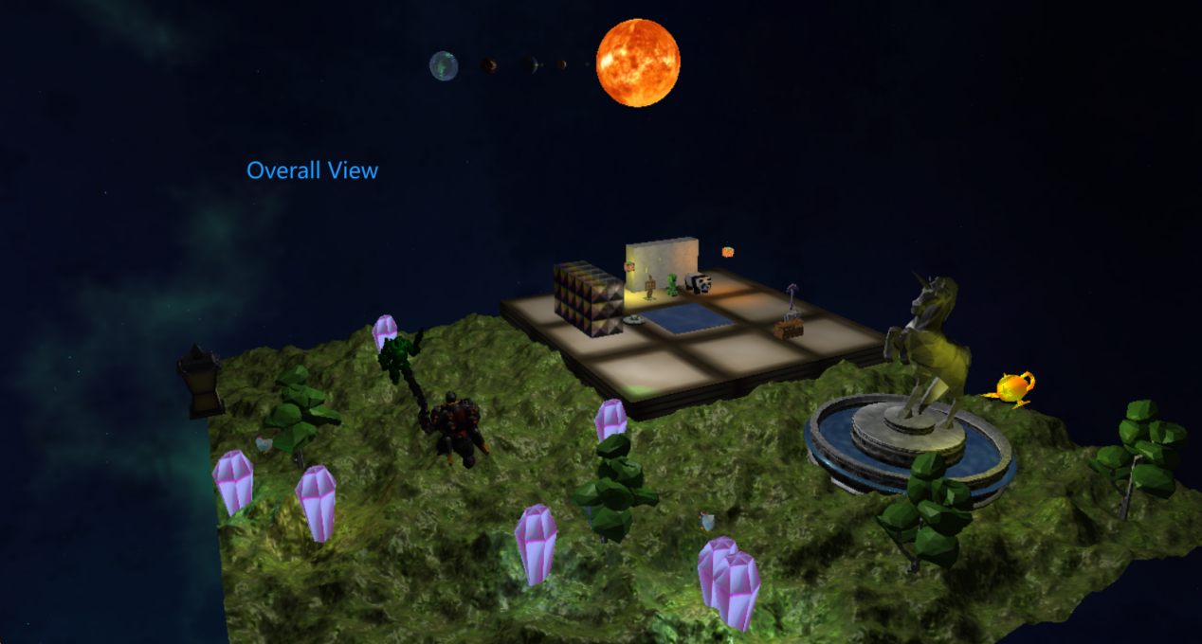

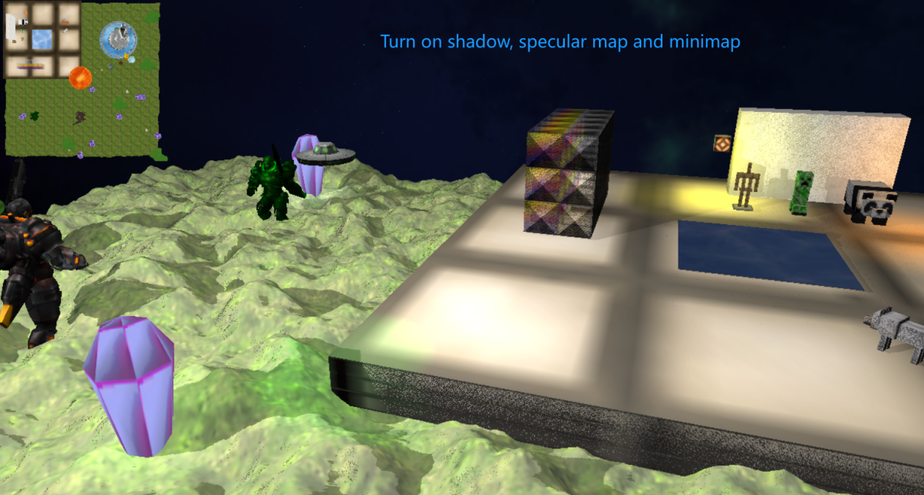

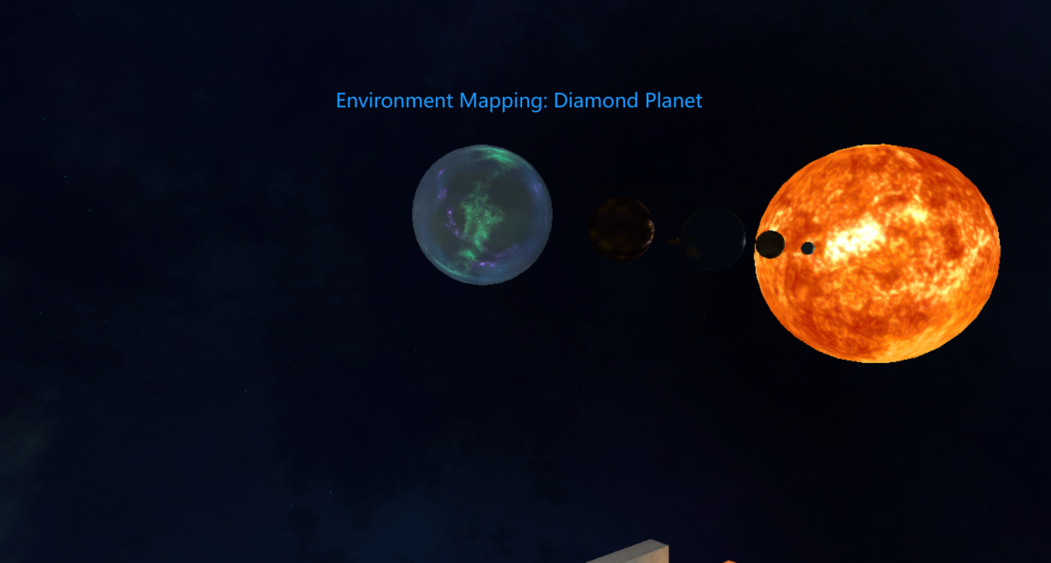

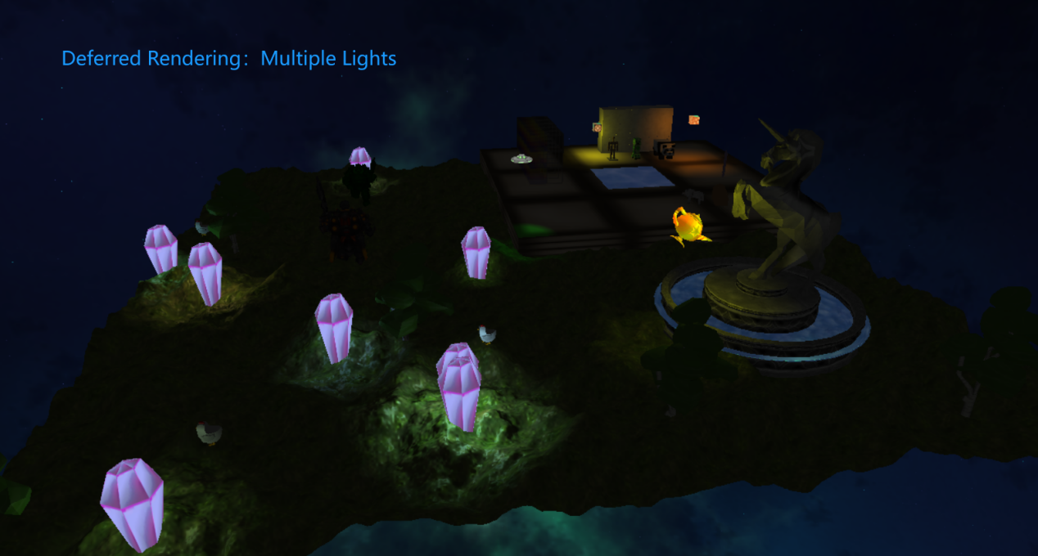

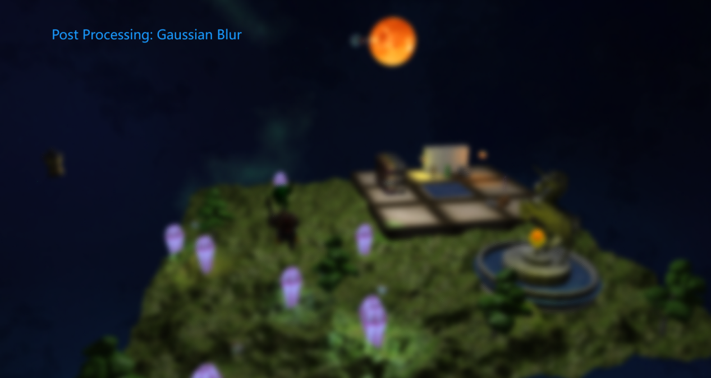

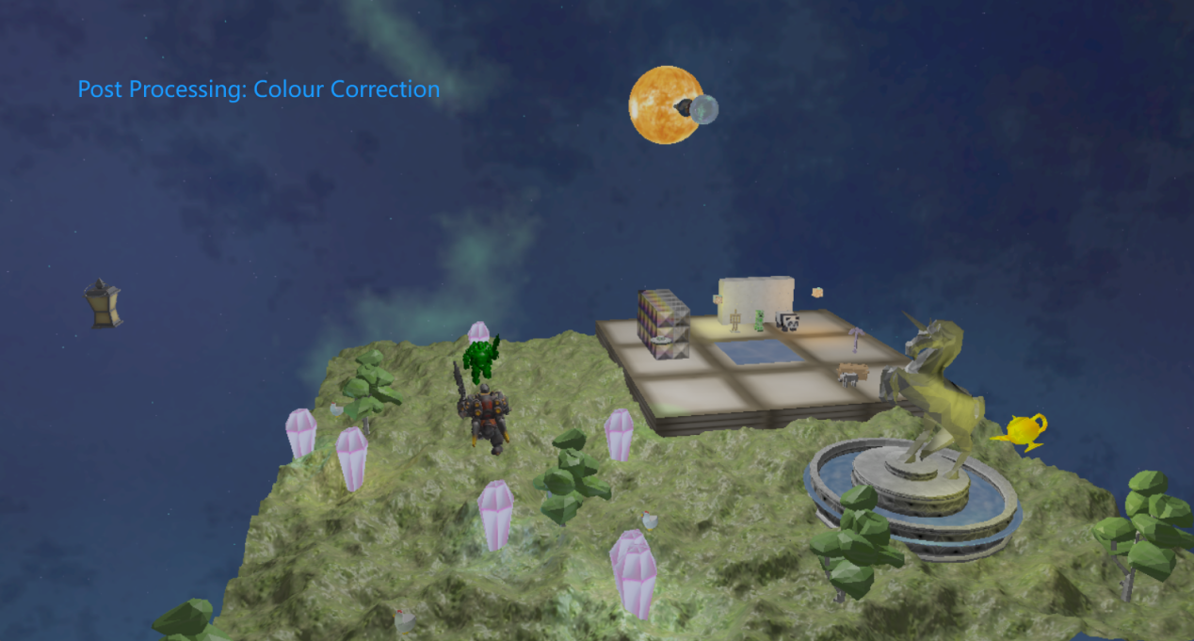

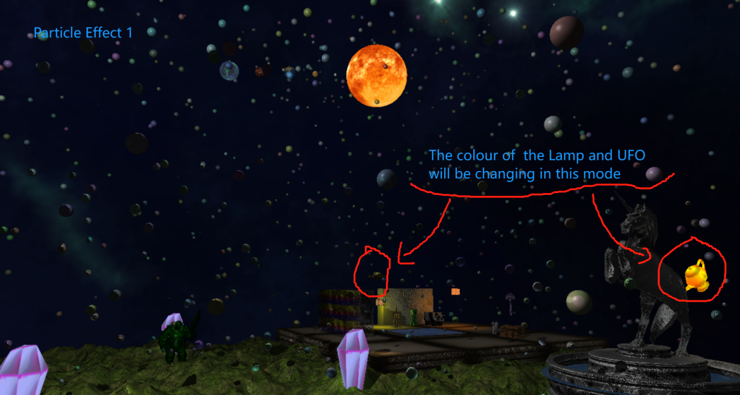

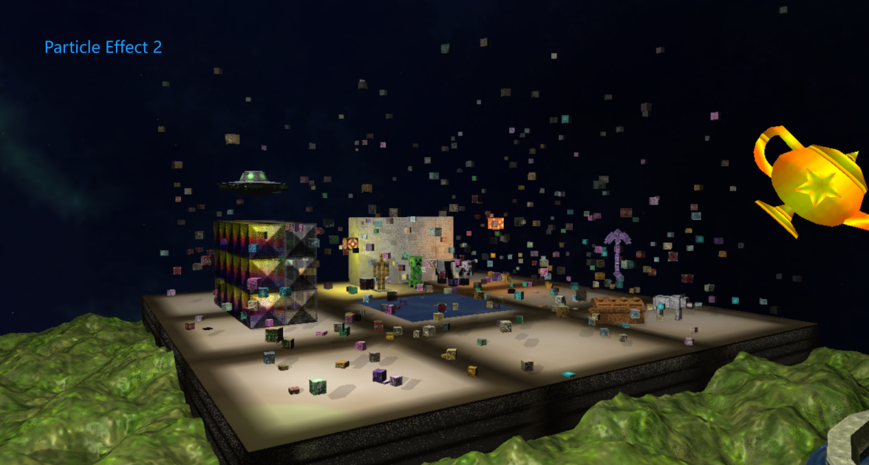

## Features:

1. Using multiple models(.msh and .obj) and textures.
2. Using height map as the terrain.
3. Using Scene Graph.

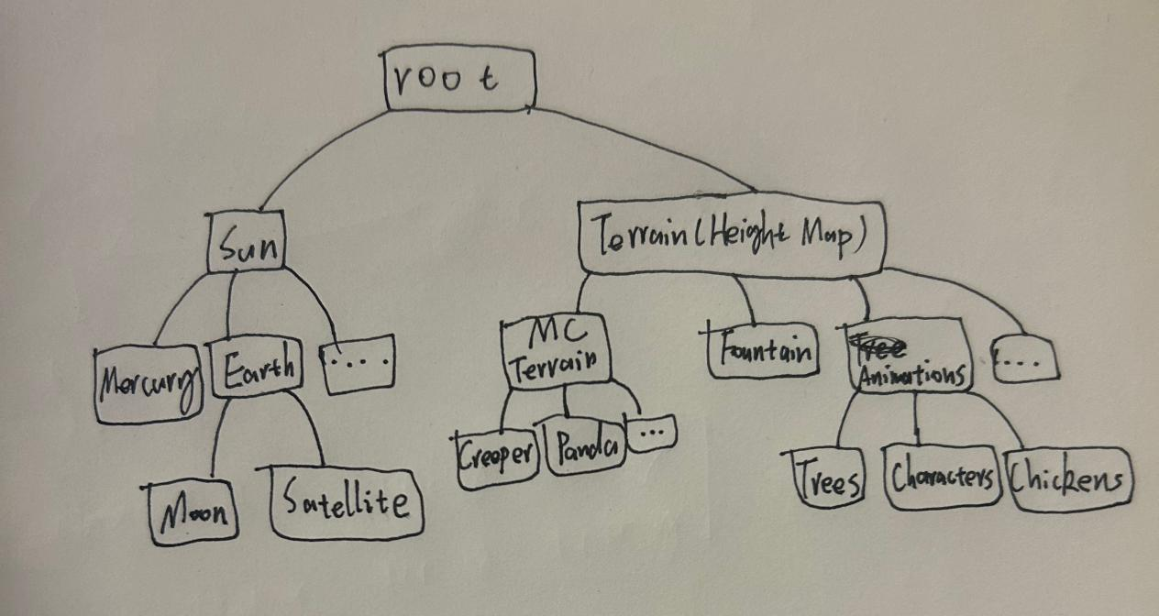

1. Using diffuse texture, normal texture and specular texture.

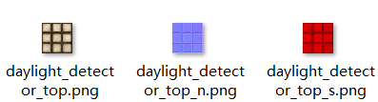

1. Three environment mapping scene nodes: fountain pool, ice and diamond planet.
2. Using scene graph and auxiliary scene nodes to perform rotation: planet/moon rotation, revolution.
3. Camera will move automatically when launched.
4. Shaders calculate ambient, diffuse, specular and emissive lights.
5. Using emissive light calculation to enable some scene nodes(Lamp/Lantern) to be lit up at any time.
6. Using multiple point lights and a spot light, which can be moved with a UFO, and its colour can be changed.
7. Using a lantern to generate a point light for real-time shadow mapping.
8. One point light moving with a Lamp, which is rotating around a statue.
9. Different shaders for different scene nodes and lights.
10. Using alpha blending for transparent blocks.
11. Using several animated meshes.
12. Using two different particle effects.
13. The colour of UFO and Lamp together with the lights moving with them will be changing when the first particle effect is turned on.
14. Multiple viewpoints: Using a top view minimap.
15. Controllable UFO: Translation, Rotation and colour changing.
16. Using two post processings: Colour Correction and Gaussian Blur.
17. Adjustable Exposure in colour correction mode.
18. Using seamless skybox.
19. Using face culling and view frustum.

## Key/Mouse:

F: Set the camera to be moving

G: Set the camera to terrain

H: Set the camera to space

W, A, S, D and Mouse: Control the movement of the camera.

I, J, K, L: Control the x and z translation of the UFO

O, P: Control the y translation of the UFO

Left, Right: Control the rotation of the UFO

V: Change the colour of the UFO

C: Change the colour of the spot light

1: Toggle the lantern light and shadow

2: Toggle the sunlight

3: Toggle the specular map

4: Enter the colour correction post processing

=: Increase exposure

-: Decrease exposure

5: Enter the Gaussian Blur post processing

6: Turn off post processing

7: Toggle the view frustum(Will be locked to true when particle effects is turned on)

F1: Toggle particle effect 1

F2: Toggle particle effect 2

F3: Toggle mini map